SIMATS ENGINEERING (SAVEETHA SCHOOL OF ENGINEERING)
Department of Computer Science and Engineering

ASSESSMENT TOOL 1 – CONCEPT MAP

Course Code: | ITA03 | Course Title: | Mobile computing
CO Assessed: | CO1 | Assessment: | Assessment Tool 1 – Concept Map
Weightage: | 60 % of CIA | Total Marks: | 20 marks
CO1 Statement: | Analyse the mobile network components, mobile base station, mobile infrastructures and protocols in cellular systems.
Student Name: | T.MEGHA HARSHA | Reg. No.: | 192424389
Section / Batch: | AI&DS | Date:
Code of Conduct

I T.Megha Harsha(192424389) (Name / Reg. No) certify that this submission is my original work and that I have adhered to the guidelines specified for this assessment. I understand that any violation of academic integrity rules will result in disciplinary action.
Signature of the Student: MEGHA
Instructions
- This test contains ONE question.
- Duration: 30 minutes (At home)

Annexure A - QUESTIONS

- Design a concept map that evaluates the significance of the fundamental concepts of mobile computing. Establish relationships among mobility, portability, wireless communication, and ubiquitous computing. Prioritize the concepts based on their contribution to mobile computing.
Justify the linking phrases used between the concepts.

- Construct a concept map that evaluates the effectiveness of the cellular network architecture. Illustrate the interactions among Mobile Station, Base Station Subsystem, and Network Switching Subsystem.
Identify the most critical components influencing communication. Justify your evaluation through meaningful concept relationships.

- Develop a concept map that evaluates the impact of frequency reuse on cellular network performance. Relate frequency planning, co-channel interference, adjacent channel interference, and network capacity. Assess the effectiveness of interference reduction techniques.
Support your evaluation using appropriate linking phrases.

- Design a concept map that evaluates the importance of different cellular access channels. Illustrate how paging, broadcast, control, and traffic channels contribute to communication. Rank the channels based on their operational significance.
Justify the relationships established in the concept map.

- Construct a concept map that evaluates the contribution of Mobile Station, Base Station Subsystem, and Network Switching Subsystem toward seamless communication.
Illustrate their interdependencies.
Assess which subsystem has the greatest influence on service continuity. Justify your conclusions using concept relationships.

- Develop a concept map that evaluates the effectiveness of the mobile network protocol stack. Illustrate interactions among protocol layers.
Assess how each layer contributes to reliable mobile communication. Support your evaluation with meaningful hierarchical relationships.

- Design a concept map that evaluates the role of the core network in delivering mobile communication services.
Relate authentication, mobility management, subscriber databases, and call routing. Determine the most influential core network functions.
Justify your evaluation through concept linkages.

- Construct a concept map that evaluates the operational efficiency of a Public Land Mobile Network (PLMN).
Relate operators, subscribers, switching centers, and radio access networks. Assess how these components collectively provide seamless connectivity.
Justify the relationships included in the concept map.

- Develop a concept map that evaluates different mobility management functions. Illustrate relationships among location update, registration, paging, and tracking. Determine which functions most effectively maintain user connectivity.
Support your evaluation with appropriate concept links.

- Design a concept map that evaluates various handoff mechanisms used in cellular networks. Compare hard handoff, soft handoff, and handoff decision parameters.
Assess their suitability for maintaining uninterrupted communication. Justify your evaluation using interconnected concepts.

- Construct a concept map that evaluates the effectiveness of roaming mechanisms in mobile communication.
Illustrate relationships among home network, visited network, authentication, registration, and billing. Assess the importance of each process in successful roaming.
Support your conclusions through logical concept organization.

- Develop a concept map that evaluates the relationship between mobility, handoff, and roaming. Illustrate their dependencies and interactions.
Determine which mechanism contributes most to uninterrupted communication.

Justify your evaluation using appropriate linking phrases.

- Design a concept map that evaluates the influence of cellular performance criteria. Relate coverage, capacity, Quality of Service (QoS), reliability, throughput, and delay. Assess which criteria most significantly affect user experience.
Justify the hierarchy established in the concept map.

- Construct a concept map that evaluates the effectiveness of various cellular system operations. Include call setup, authentication, paging, resource allocation, handoff, and call termination. Assess the contribution of each operation to overall network performance.
Support your evaluation through logical concept relationships.

- Develop a concept map that evaluates the complete mobile communication process.
Illustrate the interaction among user equipment, access network, core network, mobility management, and service delivery.
Determine the most critical stages in ensuring communication quality. Justify your evaluation with meaningful linking phrases.

- Design a concept map that evaluates the relationship between frequency reuse, interference, and network capacity.
Assess how each factor influences cellular system efficiency. Prioritize the concepts based on their impact.
Justify the relationships shown in the concept map.

- Construct a concept map that evaluates the interdependence among cellular network architecture, protocol stack, and mobility management.
Assess how these components collectively improve communication reliability. Identify the strongest conceptual relationships.
Justify your evaluation using appropriate linkages.

- Develop a concept map that evaluates resource management strategies in cellular networks. Relate channel allocation, power control, interference management, frequency reuse, and handoff management.
Assess which strategy contributes most to efficient network utilization. Support your evaluation through concept relationships.

- Design a concept map that evaluates the integration of all major concepts in mobile computing. Include architecture, protocol stack, mobility management, roaming, handoff, performance criteria, and cellular operations.
Assess how these concepts collectively support an efficient mobile communication system. Justify the hierarchy and linking phrases used.

- Construct a concept map that evaluates alternative approaches for improving cellular network performance.
Relate mobility management, handoff optimization, interference reduction, protocol efficiency, and resource allocation.
Recommend the most effective combination of techniques.
Justify your recommendation through well-defined conceptual relationships.

Rubrics for Calculation

Criteria | Weightage | Level 4 – Exemplary | Level 3 – Proficient | Level 2 – Developing | Level 1 – Beginning
Understanding of Problem Context | 20 | Clearly understands the problem and accurately identifies all  requirements | Good understanding with minor gaps | Basic understanding; some requirements unclear | Poor understanding or misinterpretation of the problem
Application of Concepts | 30 | Accurately applies appropriate concepts to solve complex problems | Applies relevant concepts correctly with minor errors | Applies basic concepts with limited accuracy | Fails to apply appropriate concepts
Problem-Solvi ng Approach | 20 | Logical, well-structured,  and efficient approach | Mostly logical approach with minor gaps | Basic approach with some inconsistencies | Illogical or unclear approach
Accuracy of Solution | 20 | Completely correct solution with proper  justification | Mostly correct with minor errors | Partially correct solution | Incorrect or incomplete solution
Clarity | 10 | Clear,  well-organized, and properly explained solution | Understandable with minor clarity issues | Limited clarity and explanation | Poorly presented and difficult to understand

Faculty In-charge | Course Coordinator | Program Director
Signature: | Signature: | Signature:
Date: | Date: | Date:

Concept Map:- Complete Mobile Communication Process

The concept map explains how mobile communication works from the moment a user makes a call or accesses the internet until the requested service reaches the user.

1. Concept map structure

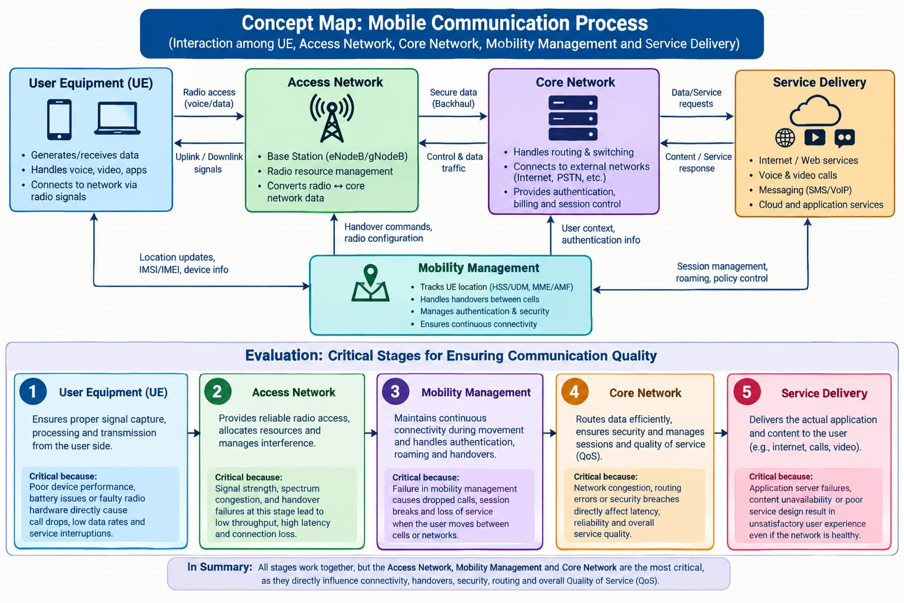

2. Meaningful linking phrases
Use these linking phrases to explain the relationships in your concept map.
Connection | Linking phrase
User Equipment → Access Network | Sends and receives data through radio signals
Access Network → Core Network | Transfers data and control information
Core Ne  twork → Service Delivery | Routes requests to the required service
Mobility Management → Access Network | Coordinates handovers between cells
Mobility Management → Core Network | Provides location and authentication information
Service Delivery → User Equipment | Returns content and service responses

3. Evaluation of the most critical stages
1. Access Network: Maintains radio connectivity and manages signal strength, interference, and available bandwidth. Poor access quality leads to dropped calls and slow data speeds.
2. Mobility Management: Maintains connectivity while users move between cells. Failed handovers or authentication can interrupt calls and data sessions.
3. Core Network: Routes data, manages sessions, and enforces security. Congestion or routing failures increase latency and reduce reliability.
4. User Equipment: Captures, processes, and transmits user data. Faulty hardware, weak device reception, or low battery can affect communication.
5. Service Delivery: Provides internet access, calls, messaging, and applications. Server failures or unavailable content can result in poor user experience.

4. Conclusion
All five stages work together to provide reliable mobile communication. The Access Network, Mobility Management, and Core Network are the most critical stages overall because they directly influence connectivity, uninterrupted movement, efficient routing, security, and quality of service (QoS). However, the most important stage in a particular situation depends on the cause of the communication problem.

